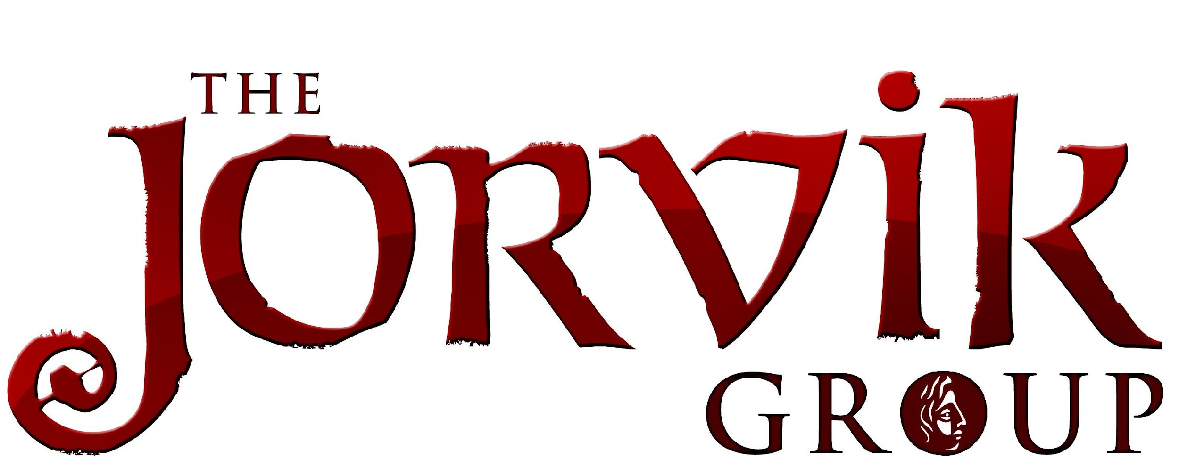

Undertaking a Placement with the York Archaeological Trust

How do I know if I want to undertake a placement or join the Trust as a volunteer?
Joining as an Attractions placement:
We have a selection of placement opportunities based at our attractions. These are offered for application and involvement at set periods during the year.
Placement opportunities suit anyone needing to undertake a block period of involvement to achieve their work experience or study aims. Our placements are usually for two – three weeks for approximately five days a week. However, some placements based in our attractions can sometimes be lengthened to meet specific course or experience needs.
How old do I need to be to join as a placement.
Our placement roles are open to anyone aged 18 or over.
If you are under 18 please speak to your local college or school about the North Yorkshire Business and Education Partnership (NYBEP) placements as we offer our opportunities to school/college aged placements via this scheme. Please note we apologise that our NYBEP placements for 2020 are now fully booked.
What skills/experience do I need to undertake a placement at the York Archaeological Trust?
For many of our placement opportunities you do not need specific experience. Anything you need to know will be passed onto you as part of your training.
The main things you will need are:
- An interest in and appreciation of the Trust and its attractions
- An interest in heritage and working in a heritage environment
- An enthusiasm for your chosen placement role
- To be happy and confident initiating interaction with people if in a visitor facing role.

In return we can help you:

- Gain valuable CV experience and new skills
- Gain experience in a heritage/tourism related field
- Be a part of the York Archaeological Trust.
- Gain department specific experience for placements, such as those based in the Curatorial department.
- An opportunity to experience heritage and tourism related jobs.

What roles are on offer?
Have a look on our website www.thejorvikgroup.com. There are ‘Get Involved’ & ‘Placements’ pages both with information about the placement roles on offer.

Getting involved in archaeology.
York Archaeological Trust also has some opportunities to assist in archaeology. Please visit our Trust website at www.yorkarchaeology.co.uk and visit the ‘Get Involved’ page.

I think some of the placement opportunities may be of interest but where can I get more in depth information?
If you are interested in a placement but would like to know a little more about what it will involve please visit our website at www.thejorvikgroup.com and look at the ‘Placements’ page for full details and role descriptions for each placement. This site also links to our individual attractions’ page for details on the attractions where the placements are hosted.

How much time do I need to undertake a placement.
The amount of time varies for each placement. Most placements are available for two- three weeks and are usually 5 days a week’ spread over a Monday – Sunday.

What happens if I would like to undertake a placement?
To ensure we offer a high level of support to all our placements we now offer new placement opportunities via set registration periods.
These periods allow potential placements to register their interest in undertaking a placement.
I would like to apply for a placement.
Wait for an application period to open and visit our website to find out which roles are available and then fill in an application form.
Application forms can be found at www.thejorvikgroup.com by going to the ‘Get Involved’ and ‘Volunteers & Placements’ page. If you would like a paper copy of the form posted to you, need help with the form or you have any questions about undertaking a placement please do not hesitate to contact us; we will be happy to talk to you on the phone or meet with you to discuss the options on offer and help you decide if you would like to apply to undertake your placement with us. Please see the section regarding our temporary closure during the Covid-19 (Coronavirus) outbreak below.

What happens when I send an application form back in?
After the application period closes we will contact all applicants to let them know if we can proceed with their application. Please note that in years with a high number of applications we may not be able to interview all applicants. If we can offer a place we will send off for your references and invite you in for a meeting to discuss the placement on offer. If you are overseas or a long distance away a telephone/video call interview may be able to be arranged.
Once we have all your references back and have met with all the applicants we can offer final confirmation on whether we have a suitable placement to offer you and will invite you to any training dates. .
Please note we cannot confirm a placement until we have a completed registration form, have received two written references for you and have met with you. This can take a little time to process so we do advise you to ensure your referees are expecting us to contact them and that you apply in plenty of time before you need any placement to start.

What happens if I have missed the application period
We regret that, due to high demand, we are unable to accept applications outside of the application periods for each year.
Should we have any additional spaces become available they will be advertised on the ‘Get Involved’ and ‘Placement’ pages of our website
Applications usually open around December for placements taking place the following January – April and from May – June for placements taking place July – October. Please note our applications for our spring and summer placements have currently been closed to new applicants following our temporary closure due to the Covid-19 (Coronavirus) outbreak. We will list updates of any future opportunities on our website once we reopen.

Do you accept applications for bespoke placement to meet set course requirements?
We work with a number of colleges and universities to offer placements linked to their courses.
Where possible we advise applications to our listed placement offers. However, where these do not meet your course requirements we may sometimes also be able to accommodate new requests for bespoke placements.
Please note we need a minimum of 8 weeks notice from the point of enquiry to when a placement needs to begin. This is to allow us time to make enquiries with the departments involved about their availability and to complete any application details needed.
At present we regret we are not accepting new applications or placement requests whilst we are temporaily closed due to the Covid-19 (Coronavirus) outbreak. We will list new information about our future capacity for later in the year once we reopen.

Contacting us.
UPDATE 25th March 2020
We are currently closed due to the Covid-19 (Coronavirus) outbreak. As such our staff are unable to access the full range of emails and telephones we usually offer.
Once we reopen we will be able to share with you contact details to ask all the usual questions and support you may require. We are sorry to be unable to offer these at this time.
If you are contacting us to request a paper copy of our Privacy Policy we will also be able to provide you with this once we reopen.
If you do need to get hold of us in an emergency you can reach us on jorvikgroup@yorkat.co.uk.

